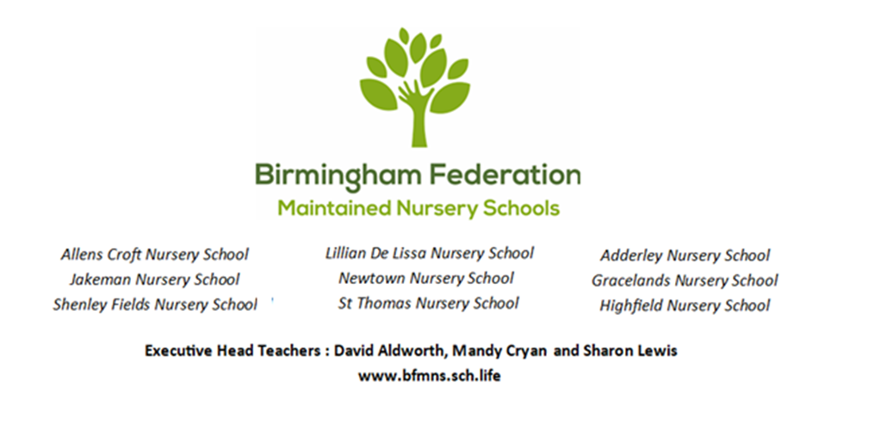
Admissions Policy
Allens Croft Nursery School

Allens Croft Nursery School follows the Local Authority guidance for admissions for the 15 hours for 2 year old children, 15 hours for 3-4 year olds and 30 hours Early Education Entitlement (EEE) for eligible families.

The school has the following places available for children:

PAN: 158 FTE places for children aged 2 – 4 years old

Free places for 2 year olds:

Birmingham City Council offers an early education entitlement for two year old children to support the most disadvantaged families in the city. Eligible 2 year olds will be entitled to 15 hours per week of provision for 38 weeks of the year, the school term after their second birthday.

Allens Croft Nursery School offers this as a two and a half (2.5) day block during term time as follows:

Big Nursery (3-4 year old children)
Monday 9.00am - 3.00pm
Tuesday 9.00am - 3.00pm
& Wednesday 9.00am - 12.00 Noon

OR

Wednesday 12.15pm – 3.15pm
Thursday 9.00am – 3.00pm
& Friday 9.00am – 3.00pm

Little Nursery (2-3 year old children)
Monday – Friday 9.00am – 12 Noon

OR

Monday – Friday 12pm – 3.00pm

OR

Monday 9.00am - 3.00pm
Tuesday 9.00am - 3.00pm
& Wednesday 9.00am - 12.00 Noon

OR

Wednesday 12.00pm – 3pm
Thursday 9.00am – 3.00pm
& Friday 9.00am – 3.00pm

Tiny Nursery (2 year old children)
Monday – Friday 9.00am – 12 Noon

OR

Monday – Friday 12pm – 3.00pm

We do not admit children of Reception age to our setting but we will work with families to support their application for a suitable school place for their child (resource base places accepted).

30 Hour Entitlement:

Our school offers those entitled to a 30 hour per week place provision between 9.00am – 3.00pm Monday – Friday. 30 hour funded places may be offered on an ‘all year round’ basis, at our discretion.

Fee Paying Places:

Parents can also pay for places at our school. Please see our handbook.

Where there are more applications than there are places available, places will be offered based on the oversubscription criteria which is as follows:

Priority 1 - Looked after or previously looked after children
Priority 2 - Siblings with an older brother or sister who attends Allens Croft Nursery School who will still be in attendance at the same time as their sibling enters the school.
Priority 3 – Children that turned three years old during the last term and are entering their first term of being eligible for the universal EEE 3 year old funding
Priority 4 - Distance from the school
If you have any concerns based on decisions made using the oversubscription criteria, please refer to our complaints policy.

See https://www.childcarechoices.gov.uk for further information on your childcare entitlement.

Date Policy Adopted:
Chair’s Actions: 24.5.2023
Full Governing Body: 26.6.2023
Date for next renewal: Autumn Term 2024

Signed: ____________________________ Sue Sidaway
Chair of Local Committee

Signed: ____________________________ Sean Delaney
Chair of Governors

Signed: ____________________________ David Aldworth
Executive Head Teacher

